Supplementary materials

from

A probabilistic framework for Windows of Opportunity:
the role of temporal variability in critical transitions

Jim van Belzen^{1,*}, Gregory S. Fivash¹, Zhan Hu^{2,3,4,*}, Tjeerd J. Bouma^{1,5}, Peter M. J. Herman^{6,7}

¹ Department of Estuarine and Delta Systems, Royal Netherlands Institute for Sea Research (NIOZ), 4401 NT Yerseke, The Netherlands
² School of Marine Sciences, Sun Yat-Sen University, and Southern Marine Science and Engineering Guangdong Laboratory (Zhuhai), Zhuhai, China
³ Guangdong Provincial Key Laboratory of Marine Resources and Coastal Engineering, Guangzhou, China
⁴ Pearl River Estuary Marine Ecosystem Research Station, Ministry of Education, Zhuhai, China
⁵ Faculty of Geosciences, Department of Physical Geography, Utrecht University, 3508 TC Utrecht, The Netherlands
⁶ Department of Hydraulic Engineering, Delft University of Technology, 2628 CN, Delft, The Netherlands
⁷ Unit of Marine and Coastal Systems, Deltares, 2600 MH, Delft, The Netherlands
* corresponding authors

Supplementary material
Content
- Note 1: Statistical properties of dichotomous environmental signals
- Note 2: Derivation critical growth rate
- Note 3: Establishment in systems with growth and decay of tolerance
- Note 4: Linear versus exponential growth
- Note 5: Estimating establishment chances and coverage
- Note 6: Ornstein-Uhlenbeck noise

Note 1: Statistical properties of dichotomous environmental signals
Here we focus on the description of environmental fluctuations in terms of the average E_{avg}, period τ, variance σ²(E) and temporal autocorrelation ξ(t’) and how they can be derived from the parameters making up the regular dichotomous signal and the dichotomous Markov noise signal respectively.
Regular dichotomous signal
The variability of environmental fluctuations can be described using period τ and variance σ²(E) as the two key attributes reflecting the temporal and magnitude of the signal. First, we define the period τ of the regular dichotomous signal as:
τ = τ_{low} + τ_{high}
The variance of the signal, reflecting the magnitude of the environmental fluctuations, can be calculated using:
σ²(E) = (τ_{low}E_{low}²)/τ + (τ_{high}E_{high}²)/τ - E_{avg} ²
Herein, the average environmental condition of the regular dichotomous signal E_{avg} is calculated as:
E_{avg} = (τ_{low}E_{low} + τ_{high}E_{high})/τ
We do not give the autocorrelation function for this signal.
Dichotomous Markov Noise
In case of the Dichotomous Markov Noise we first need to define the finite correlation time of the environmental signal, which is:
τ_{c} = 1/(k_{low} + k_{high})
Next, we also need the approximate period:
<τ> = 1/k_{low} + 1/k_{high}
The average environmental condition of the DMN can now be easily found as:
E_{avg} = (k_{low}E_{high} + k_{high}E_{low})τ_{c}
The variance in this environmental signal can be found as:
σ²(E) = (E_{low}²/k_{low})/τ + (E_{high}²/k_{high})/τ - E_{avg} ²
The temporal autocorrelation function of the DMN is exponentially-decaying:
ξ(t’) = (D/τ_{c})exp(-|t-t’|/τ_{c})
Here, the noise amplitude is:
D = k_{low}k_{high}τ_{c}³(E_{low}+E_{high})²

Note 2: Derivation critical growth rate
To derive the critical growth rate λ_{crit} -i.e., the minimum growth rate just needed to allow successful establishment- we first need to define the critical tolerance T_{crit} that needs to be reached for successful establishment. The critical tolerance is the tolerance that the system at least needs to have to survive the environment. In the simple dichotomous example (Fig 1) the tolerance should be equal or higher than the maximum environmental condition E_{high} after the time interval at which the environment is low τ_{low}, thus:
T_{crit} = E_{high}
The development of tolerance, in the case of linear growth, can be derived using:
T = T₀ + λτ_{low}
In case of exponential growth of the tolerance:
T = T₀e^{λτ_low}
In case of linear growth, the critical growth rate can be derived by the following:
E_{high} = T₀ + λ_{crit}τ_{low}
λ_{crit}τ_{low} = E_{high} - T₀
λ_{crit} = (E_{high} - T₀) /τ_{low}
For simplicity we define the difference between the initial tolerance and the maximum environmental condition as the tolerance threshold that needs to be crossed:
δ = E_{high} - T₀
So, we get the relationship in case of linear growth of the tolerance:
λ_{crit} = δ /τ
In case of exponential growth, the threshold parameter reads:
δ = lnE_{high} - lnT₀
Consequently, this means that in case of simple linear growth of tolerance knowledge about the threshold δ suffices, while in case of exponential growth also the magnitude of the initial tolerance T₀ becomes an important parameter determining the critical time window τ_{crit} and/or critical growth rate λ_{crit} required to successfully establish (see Supplementary Note 4).

Note 3: Establishment in systems with growth and decay of tolerance
To encapsulate the concept of stage-dependent tolerance in the theoretical framework, we assume that if the organism’s tolerance (T) to the environment (E) has not developed high enough before the environment returns to a harsh condition again, returning to the high condition (thus T < E at τ_{low}), it dies instantaneously (Fig.1, lowest green arrow with red cross at death). This assumes that the rate at which the tolerance decays (ε) during the harsh conditions is many orders of magnitude higher than the scale on which growth occurs (i.e., develop tolerance, λ). In this way, we focus our framework thus on the interval (i.e., time windows) of benign conditions (τ_{low}) and when they can become an actual WoO. The length of harsh period (τ_{high}) is thus not considered and can either be very short or very long. In this supplementary note we develop some further insights about the special case in which the timescales of growth and decay are of equal magnitude.
In the case that growth and decay of tolerance during benign and harsh environmental conditions are of similar orders of magnitude not only the intermittence (i.e., the length of the benign window) but also the duration of the harsh environmental conditions matters for the possibility of the organism to establish. Here we will show that although the specifics of these dynamics are different from the case discussed in the main text of the manuscript, the overall rules we derived are very comparable. Therefore, we focus on the situation with a regular dichotomous signal (RDS) but will not develop this further for establishment in an environment with Dichotomous Markov Noise (DMN). We add the effect of the decay of tolerance during periods of high environmental conditions E_{high}. In the conceptual approach we posed in the main text we assumed that an organism dies immediately if E>T. Here we change that assumption so that an organism dies when T<T₀. Furthermore, when E<T the organism can develop tolerance at rate λ and in case E>T tolerance will decay at rate ε. The development of tolerance, in the case of linear growth, can then be derived using:
T = T₀ + λτ_{low} – ετ_{high}
From this equation it can be easily understood that organism cannot survive and establish if λτ_{low} < ετ_{high}.
When the periods of low and high environmental conditions are stochastic and variable over time, like in de DMN signal, decay of tolerance can be understood as a legacy effect, meaning that the organism (or system) becomes more vulnerable with the repeated return of the harsh condition E_{high}.

Note 4: Linear versus exponential growth
The way how organisms develop tolerance over time is a key factor that determines their sensitivity to fluctuations in environmental conditions. Here, we compare the linear and exponential growth types to get a general intuition about how the growth type in relation to environmental variance opens or closes WoOs (Fig.S1a). As the main text focusses on linear growth. we focus on explaining the exponential growth in this supplementary note. Determining establishment in case of exponential growth is a bit more complicated and the dynamics are richer than the case for linear growth. We first reveal how the results for exponential growth differ from linear growth followed by a discussion how relevant linear and exponential development of tolerance is found to be in current literature.
Results
Overall, the results for linear and exponential growth are similar, in that larger environmental variance σ²(E) require longer benign periods τ_{low} or higher critical growth rates λ_{crit}. Yet, the exact result of the exponential growth is more sensitive for the initial tolerance T₀. For the specific example displayed here the exponential growth (blue line Fig.S1b) requires higher rates to establish at low environmental variance σ²(E) values compared to the linear growth (green line Fig.S1b). However, exponential growth is less sensitive to increasing variance than linear growth. Consequently, in relatively high variable environments σ²(E) lower growth rates are required to establish for organisms growing exponentially compared to those growing linear. These results are however specific for the initial tolerance values and the specific environmental conditions of E_{low} and E_{high}. Shifting the environmental conditions E and initial tolerance T₀ to 50% higher(/lower) values reveals that the organism can establish at lower(/higher) growth rates (Fig. S1b). Further moving these values to higher levels can shifts the critical growth rates to below that of the linear critical growth rate (green line, Fig.S1b). Similar shifts do not affect the curve of the critical growth rate for linear growth. Hence, these results indicate the difference in sensitivity to the magnitude of the environmental variance between linear and exponential development of the organism’s tolerance.
The response of linear and exponential growth, and change thereof, to the magnitude of the benign period τ_{low} is similar (Fig.S1c) in contrast to the environmental variance σ²(E). Again, the exact values are specific for the initial tolerance values and the specific environmental conditions of E_{low} and E_{high}., determining if they are above or below the curves of the linear growth. But the overall sensitivity (shape of the curve) is the same. This is further underlined by the fact that doubling or halving the threshold δ results in a similar shift of the curves for both organisms with linear and exponential growth. Consequently, this comparison again underlines that the temporal autocorrelation structure, which is related to the timing of the signal and length of the benign period τ_{low}, is the key factor determining if windows open or close and stable establishment can occur.
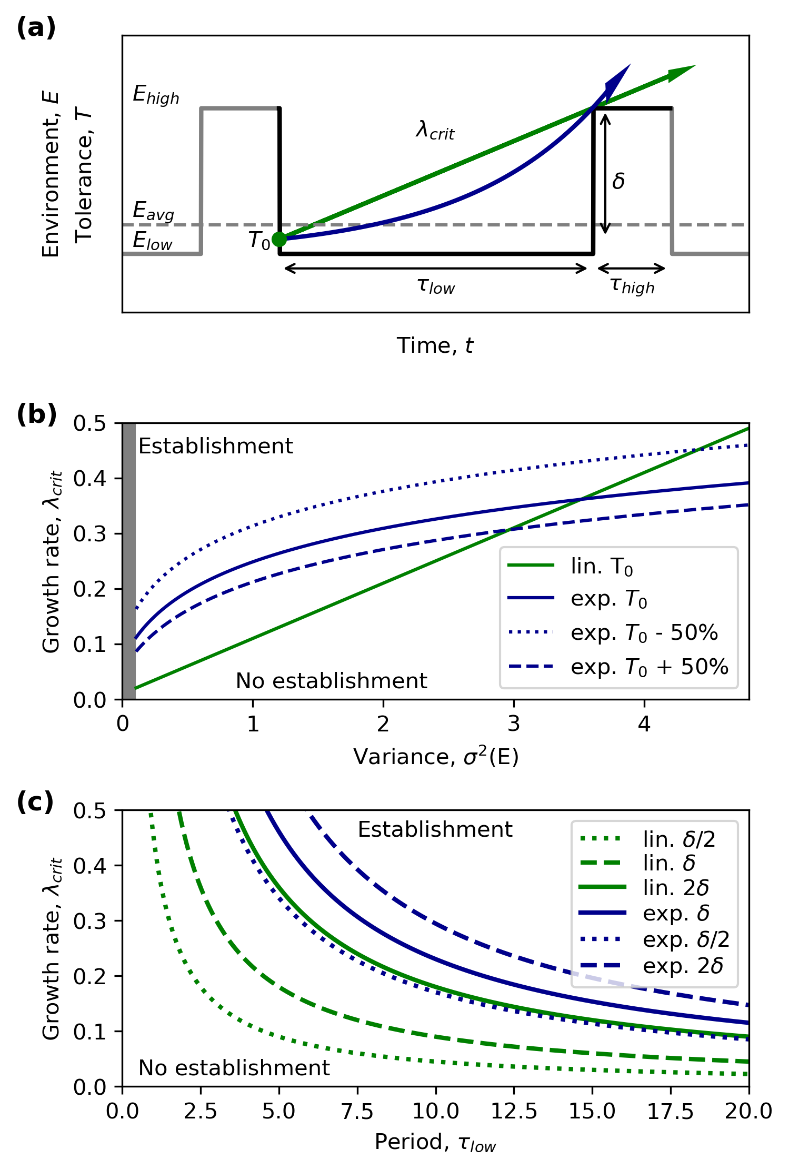
Figure S1. Critical growth conditions for transitions towards establishment.
(a) Conceptual framework for WoO with organisms developing tolerance linear (green arrow) and exponential (blue arrow). The organism (colored arrows) needs to overcome threshold δ to establish. The inclination of arrows depicts the critical growth rate λ_{crit} just high enough to be successful. (b) Critical growth rate at increasing variance. The gray area depicts the region where variance levels are too low and do not create WoOs. The white area is the region where WoO are created by environmental variance given that the growth rate is sufficiently high. (c) Critical growth rate with increasing benign period length.
Discussion
In case of the exponential growth of tolerance the dynamics are richer and the initial tolerance T₀ becomes an important 4th factor to consider (Supplementary Note 2). However, based on various works considering environmental tolerance at young life stages we see that linear growth is a reasonable assumption (e.g., Pandori & Sorte, 2019 and references therein). A clear-cut example is demonstrated by the recent work on seedlings establishing on tidal flats of variable bed-levels due to hydrodynamic forcing. Although the development of biomass (i.e., dry mass) was exponential in the mesocosm experiments, the tolerance to sediment erosion (i.e., termed ‘critical erosion depth’ in these studies) developed linearly over time as function of the rooting depth (Balke et al., 2011; Bouma et al., 2016; Cao et al. 2018; Hu et al., 2015). It moreover has didactical advantages to develop a sound intuition about the dynamics at hand and therefore to ignore exponential growth in the main text.

Note 5: Estimating establishment chances
In this supplementary note we demonstrate how to estimate establishment chances and coverage once the probability that a Window of Opportunity (WoO) occurs (P_{WoO}) is known (e.g., using equation 4) or the fraction of the attainable time WoO’s occur (f_{WoO}) is derived from the signal (e.g., as numerically derived from the continues signal synthesized using Ornstein-Uhlenbeck noise).
When evaluating the probability P_{WoO} of WoO’s occurring in a fluctuating environment we ultimately want to estimate what the effect of the occurrence of WoO’s is on the actual probability of establishment P_{est}. This can be done by scaling the background establishment probability p₀ for the fraction of the attainable time WoOs occur f_{WoO} as follows:
P_{est} = 1 – (1 – p₀)^{fWoO}
Here the background establishment probability p₀ is estimated for the individual organism under benign conditions, i.e., the probability that an organism can establish when the environment permanently has a stress value lower than T₀. As only a (small) fraction of the time WoO’s can occur (f_{WoO} = P_{WoO}τ_{low}/(τ_{low} + τ_{high})), the establishment probability P_{est} is by definition (much) smaller than the background establishment probability p₀.

Note 6: Ornstein-Uhlenbeck noise
Model description
The Ornstein-Uhlenbeck process (eq.5) was used to generate various synthetic correlated Gaussian noise signals that mimic many natural variable signals in nature (Hasselmann, 1976; van Nes et al., 2007). To generate a synthetic signal the simulation was run for 1,000 time steps with a dt of 0.01. Default settings of the model were μ = 1, τ = 1, and σ²(E) = 1. Because for OUN the variance of the signal σ²(E) is also affected by changes in the approximate period τ (i.e., larger τ results in larger σ²(E) at constant ε) we scaled the noise level ε to normalize the variance of the signal by using the numerically derived relation:
ε = σ²(E)/(0.74(τ /dt)^{0.493})
By scaling the magnitude of the noise ε this way we could investigate the separate effects of changing the average and approximate period of the environmental signal. A total of 1,000 random environmental signals were generated to test how many of the windows are large enough to become attained by organisms at a certain growth rate λ. Moreover, the tolerance of the organism was initiated at T₀ = μ /10 for all simulations.
Model analysis
To investigate the effect of the approximate period τ on the establishment chances we ran simulations for the default approximate period, 10 times longer and a 10 times shorter period, while keeping the variance σ²(E) constant. To investigate the effect of the variance σ²(E) on the establishment chances we ran simulations for the default variance, 2 times smaller and a 2 times larger variance, while keeping the approximate period τ constant. We focused the analysis on obtaining the fraction of attainable windows f_{WoO}, which is the relative number of windows that can potentially be occupied by an organism at a specific growth rate λ. This was considered to serve as a reasonable proxy for the establishment chances P_{est}. In this model a window was defined as the time interval from E < T₀ to E > T₀, and thus the attainable window is defined as the window where T > E when E > T₀. Each synthetic environmental signal was probed for the fraction of attainable windows f_{WoO} by gradually ramping up the growth rate λ from 0 to 2.5 with steps of 0.1.

